Midterm Solved by
CHULBULI TITLI, HIRA AFTAB , MIKE ALI,
5. Assume that demand for a product is inelastic, will consumer expenditure go on increasing as price rises? 3marks
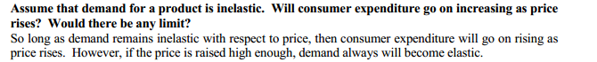

4. Define the key ingredients of any market structure .3marks
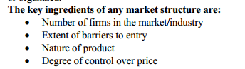
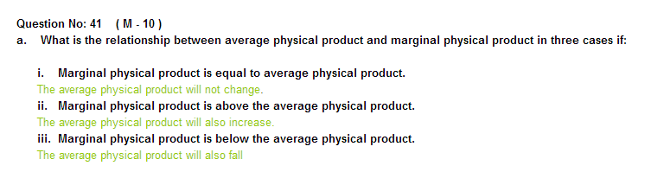
1. Explain the relationship between income and elasticity demand of inferior goods. Explain with the draw of graph. 5 marks
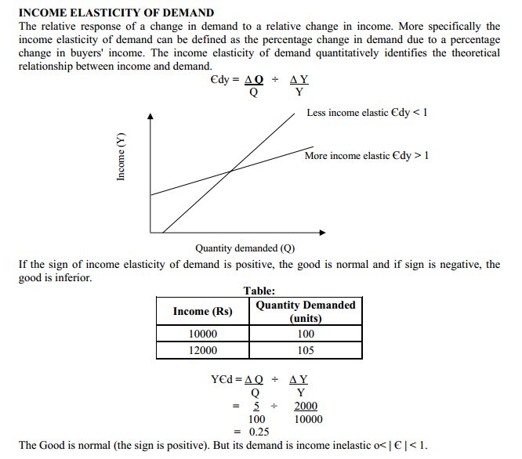
ECO401 - Economics - Q.No. 36 ( M - 5 )
Compare the characteristics of perfect competition and monopolistic competition with examples.
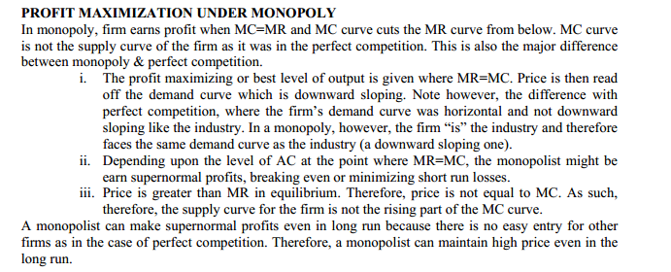
ECO401 - Economics - Q.No. 36 ( M - 5 )
What are the two main theories of production regarding time?
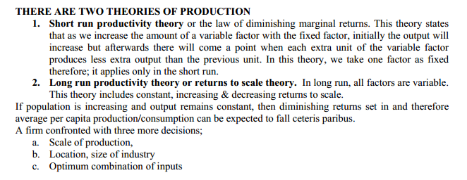
ECO401 - Economics - Q.No. 35 ( M - 3 )
Why economists believe that when firms earn zero accounting profits, they actually earn normal economic profits?
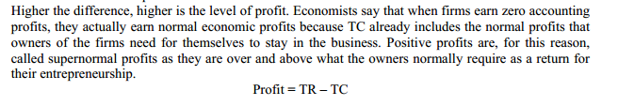
ECO401 Question No: 36 ( M - 5 )
Write down the advantages and disadvantages of monopoly.
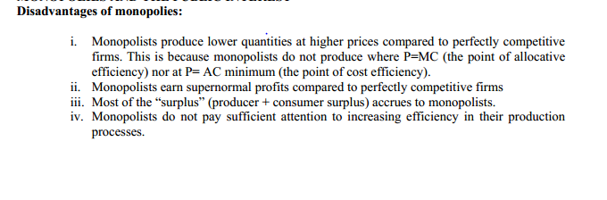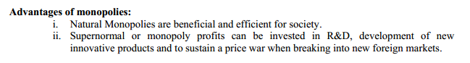
ECO401 Question No: 35 ( M - 3 )
Briefly explain the relationship between monopoly power and price elasticity of demand.
Answer:
Market power is the ability to raise price above marginal cost and earn a positive profit. The degree to which a firm can raise price above marginal depends on the shape of the demand curve at the profit maximizing output. That is, elasticity is the critical factor in determining market power.
The relationship between market power and the Price Elasticity of Demand can be summarized by the equation:
P/MC = PED/(1 + PED)
PED will be negative, so the ratio is always greater than one. The higher the P/MC ratio, the more market power the firm possesses. As PED increases in magnitude, the P/MC ratio approaches one, and market power approaches zero. The equation is derived from the monopolist pricing rule:
(P - MC)/P = -1/PED

QNO2;EXPLAIN MONOPLY POWER MARKS 3
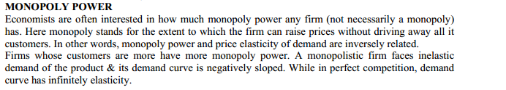
3. Give the degree of discrimination of the following
a. an electric power supply company uses block prices for electric sales.
b. An airline company charges different ticket rates to passengers
c. Tennis court owner charges different from child and young ones
d. Producers sells commodity abroad at lower price and higher price in local market
e. Doctor charges high prices to rich than poor.
4. What would be the shape of indifference curve in each of the following?
a. A, B are two brands of the same product, consumer can not tell the difference whether which is good or preferred.
b. X is good and Y is bad like household refuses.
Lesson21

2. Explain the traditional theory of firm with the help of its basic equation.
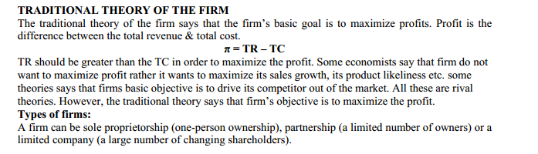

. Equation of total revenue (TR) is given below
TR = 100Q – Q2
If Q =3 than calculate average revenue and slope of average revenue.
i. TR = P x Q.
ii. AR = TR/Q; AR is usually equal to price unless the firm is engaged in price discrimination.
iii. MR = ∆TR/∆Q.

How can we achieve optimum combination of factors of production if: 5 Marks

MPPk > MPPL
PK PL
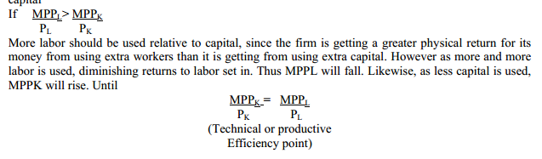
How the principle of diminishing marginal rate of technical substitution is related to the law of diminishing returns. 3 Marks
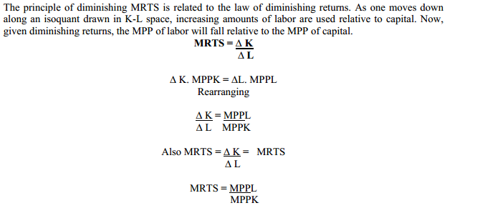
Why would you expect additional advertising dollars spent by a firm to cause smaller and smaller
increases in sales? In other words why should advertising suffer from “diminishing returns”?
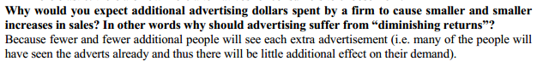

Question No: 36 ( Marks: 5 )
Write down any five situations in which cartel can survive?
Ans:1) Cartel can survive when number of firms is small.
2) When the collusion is tacit or hidden not explicit.
3) The products are homogeneous.
4) Industry is sable
5) There is opening among the firms regarding their production
process.
6) Government’s strictness in implementing antitrust law.

Question No: 37 ( Marks: 5 )
Differentiate between external economies of scale and external
diseconomies of scale with the help of examples.
Ans:
External economies: These are the benefits which are accured to
any firm in the presence of other firms. For example setting of credit
information bureaus by bank , advertising by industry such as rival
industry.
Discovery of new techniques.
This type of economy occurs when an industry is heavily concentrated
in a particular area.
Economies is available to all firms for example construction of roads
External diseconomies of scale :
These are the forces which causes the large firms to produce goods
and services at increased per unit costs.
This type of scale occurs when an industry grows larger and shortage
of skilled laor taking place and shortage of raw materials are the types
of external diseconomies.
When a firm become large then supervision of workers become difficult
and problem is created for management is taking place which cause
adverse effect on efficiency

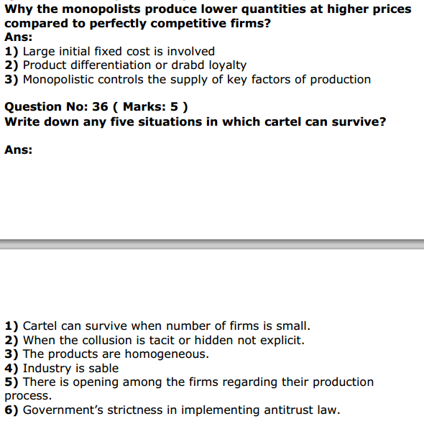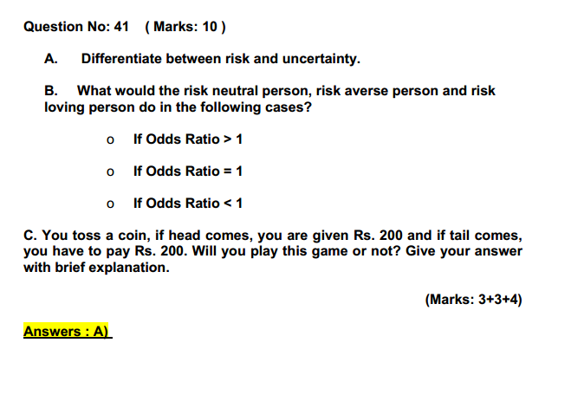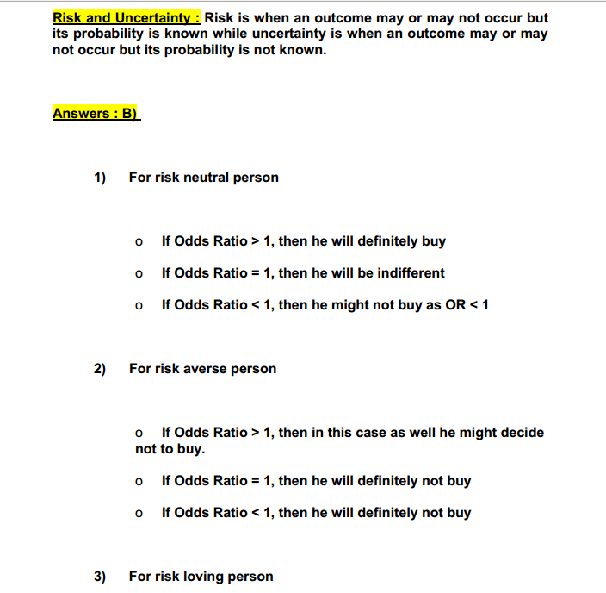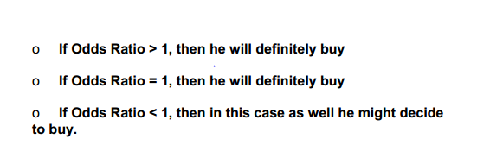.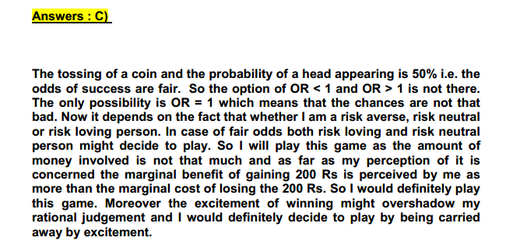
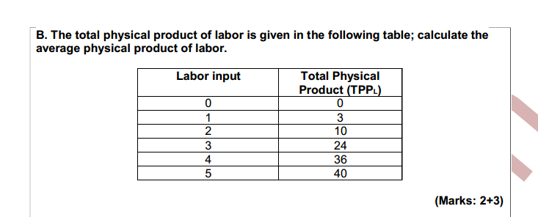
Pg: 54

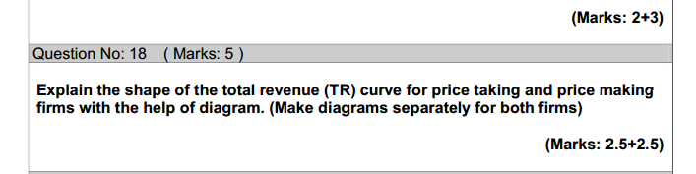
Pg :63

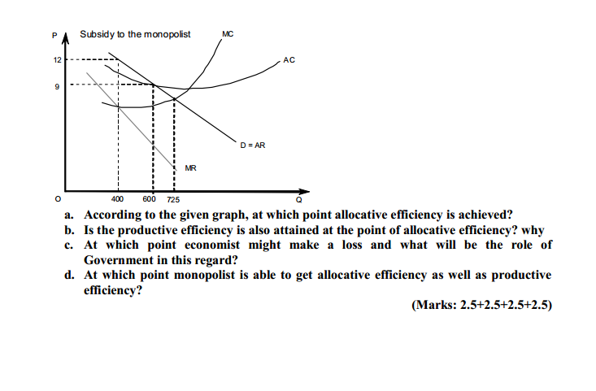
P:76

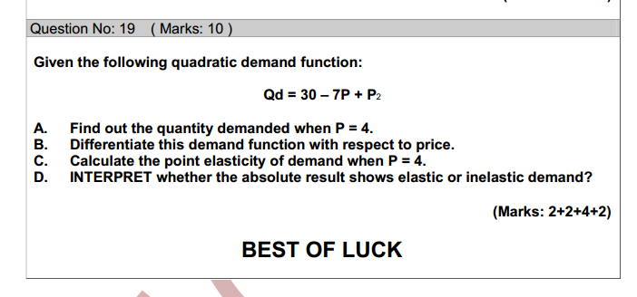
Pg:26
Economics 401 dated : 13.01.2015
18 MCS
2 Questions( 3 marks each) 3 Question ( 5 Marks each)
1) define sunk cost with an example? 3 Mrks
2) explain the figure (given) ? it was the figure when the firm makes the super normal profit given in the slides of the lecture 18.. 3 Mrks
3) Define the variable cost and fixed with the help of examples? 5 Mrks
4) explain the limit pricing with the help of given figure ( at book lecture 20) 05 Mrks
5) draw the vertical and horizontal curve? what are their elasties ? 5 Mr
MCQs ND Subject Cover all this topics
Firms/household
Demand
Supply
Supply Curve/demand
Equiliburim
Elasticity
inletic
MArginal utility
RIsk
Slope
paper date: 12/1/2015
total 23 questions
17 mcqs 1 marks
3 questions 3 marks
2 question 5 marks
1 question 10 marks
mcqs mostly from lesson 3,5,6,11,15 to 17
questions
3 marks
SUNK COST with example
at what point monoploy is same as perfect compition explain with example on the basis of long and short run
===============================================
5 marks THE LAW OF DIMINISHING MARGINAL RETURNS
and calculate Marginal physical product (MPP) from the given
Average physical labor(APP)The total physical labor (TPP)
calculate PROFIT MAXIMIZATION by
Given the following equations:
TR = 72Q – 2Q²; TC = 10 + 12Q + 4Q²
Calculate the maximum profit output and the amount of profit at that output using MR & MC APPROACH
==========================================
10 marks Qs = 60 + 15P + P²
(a)diffrentiate the given eq with respect to price.
(b)price elasticity of supply when the given price is 5.
(c)Draw the supply curve

