CS101 Introduction to Computing

Mid Term Examination - April 2003
Session -1

Q.No 1
An object can be defined as

- Collection of integers and floats
- Collection o of integers and properties
- Collection of While loops and variables
- Collection of properties and methods
- Combination of sequential and conditional structures
Q.No 2
During the integration and testing phase of software development life cycle

- User documents the work that he thinks the system does
- Developer analyzes user's requirements, and perform further
- investigation to write the specifications for the system
- Bring the subsystem together to form the systems and test them
- Detailed plan specifying the required resources and expected
- deliverables
- Providing the feasibility of the system
Q.No 3
The advantage of client side scripting is

- All browsers support it
- Decreases the complexity of web page
- Reduces network traffic
- Increases server load
- User cannot see your code
Q.No 4
Spreadsheet software

- Is the replacement of ledgers
- Is a replacement of encyclopedia
- Are not used for business calculations and charts
- Is a sub category of science, engineering and graphics software
- Is a sub category of entertainment software.
Q.No 5
Decision support systems are sometimes called
- ERP
- Document-centered computing
- E-commerce software
- Electronic Encyclopedia
- Expert Systems
Q.No 6
ASP script is

- A data base management system
- Not a server side script
- Linux based server script
- Window based server script
- Unix based server script
Q.No 7
Software that directly interact with the user is called

- System software
- Application software
- Low level languages
- Machine language
- Compilers
Q.No 8
In the AND operation output is true if

- All input variables have true state
- Some of the input variables have true state
- None of the input variables have true state
- All the input variables have false state
- Only one of the input has false state
Q.No 9
Semantic web pages

- Are also called static web pages
- Are not understood by computers
- Are understood by computers
- Are not the extension of today's web pages
- Correct the semantics of the web page
Q.No 10
Two major types of software are

- Application Software, System Software
- Application Software , Database Software
- System Software , Database Software
- Database Software , Embedded Software
- Database Software , Embedded Software
- Q.No 11
Language that is understood by computer hardware is called

- High level language
- Firmware
- Machine language
- Assembly language
- System software
Q.No 12
Microprocessor are made up of semiconductor material called

- Aluminum
- Copper
- Ferrous oxide
- Silicon
- Silicon dioxide
Q.No 13
The following code will
<Html><HEAD>
<TITLE>
My new Web Page
</TITLE>
</HEAD></Html>

- Display "My new Web Page " As a heading on my Web page
- Display "My new Web Page " On the title bar of the browser
- Display "My new Web Page " as a hyper link
- Make "My new Web Page " appear in bold letters
- Not display "My new Web Page
Q.No 14
In an HTML file, it is essential to have

- <Head> tag
- </Body> tag
- <Body> tag
- <B> tag
- None of above
Q.No 15
A unique identifier for the location of a specific Web page is called a

- FTP
- FAQ
- URL
- http://
- IRC
Q.No 16
Search engines
- Cannot search the entire web
- Are built to facilitate the scientists
- Make the list of images that are available on the net
- Search the news groups for the required information
- Scan the entire web for the desired information
Q.No 17
A web site

- Does not have a unique identifier
- Is accessible to limited user
- Is a collection of related documents on the internet
- Is a place where we can only read information on the internet
- Is a place on the net where we can only write information
Q.No 18
Vacuum Tubes are

- Smaller then transistors
- Developed for military applications
- Made up of two or more electrodes in a glass metal tube
- Used in IBM PC
- Invented by Tim Burners lee
Q.No 19
BASIC stands for

- Basic American Standard Information Code
- Beginners All purpose Symbolic Instruction Code
- Brother and Sisters In Christ
- British American Scientific International Commercial
- Badminton And Swimming Including Cycling
Q.No 20
JavaScript

- is an Object based Language
- is an interpreted language
- Both first and second
- is an Object-Oriented Language
- Both second and fourth
Q.No 21
World's first program was written by

- Charles Babbage
- Alfred Tennyson
- Ada Lovelace
- Bernouli
- Newton

Q.No 22
What would be the output of the following Pseudo Code? (3 Marks)
Start
Initialize x to 4
Initialize y to 1
Initialize Result to 0
While (y<=x)
Result=x+y
Y=y+1
Loop
Print Result
End
- 4
- 8
- 10
- 1
- None of the above
Q.No 23
Convert binary number 100100 into equivalent Decimal number. (5 Marks)
Q.No 24
Write the truth table for Boolean Expression. (5 Marks)
Z= x + (x. y)'
Q.No 25
Take a look at the image of the browser screen shown below. Write down the
HTML code that will produce this screen. (15 Marks)

MIDTERM EXAMINATION
FALL 2006
Marks: 40 Time: 60min

Question No: 1
Computer uses the scanner to input
- Voice
- Images
- Voice and text
- None of these
Question No: 2
Software is
- Something that can be touched
- Something that cannot be touched
- Something used only as an output device
- Something used only as an input device
Question No: 3
What is internet?
- A global network of networks
- A Software used to connect to some network
- A group of users
- Any network of more than two computers
Question No: 4
Which of the following is a type of system software?
- Device driver
- Word processor
- Write once read -only- memory
- Anti-Virus
Question No: 5
- HTTP is the abbreviation for:
- Hyper text transfer protocol
- Hyper text terminal protocol
- Hyper text transmit protocol
- Hyper terminal text protocol

Question No: 6
Which of the following is called the brain of computer?
- Motherboard
- Slots
- Processor
- Power supply
Question No: 7
a) Convert the following numbers from decimal numbers into binary numbers:
(Marks: 6)
1. 24
Answer = ____________________
2. 55
Answer = ____________________
3. 84
Answer = ____________________
b) X, Y is Boolean variables. Determine the truth tables for the following combinations:
(X . Y)’
(Marks: 6)
Question No: 8 (Marks: 12)
a) What is the difference between Desktop Computer and Super Computer? Give at least three differences (Marks: 6)
b) Write an Algorithm to compute the final price of the item. It will ask two inputs from the
User i.e. Price of item and the sales tax rate. You have to calculate the final price of the item.
(Marks: 6)
Question No: 9 (Marks: 10)
Write the HTML code that will generate the similar page as shown below. You have to put the form elements with in the table.

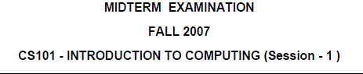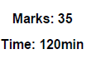

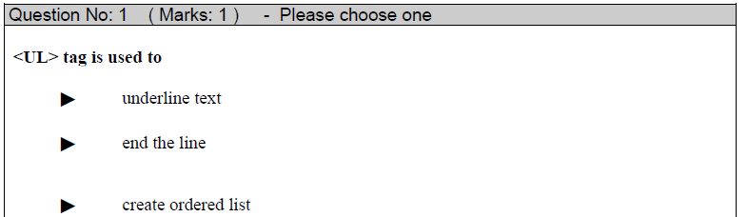


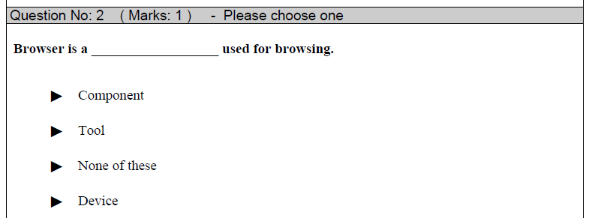
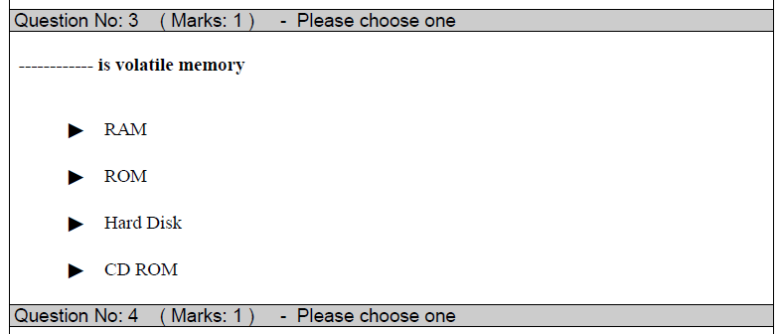
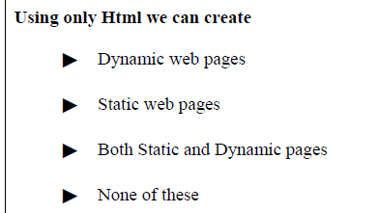

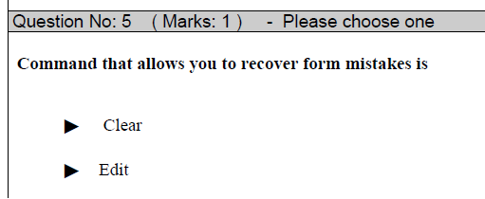
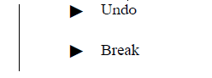
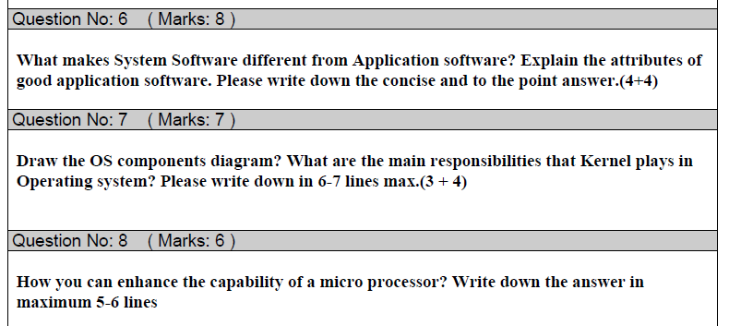
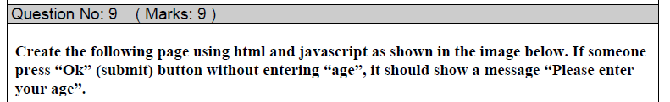
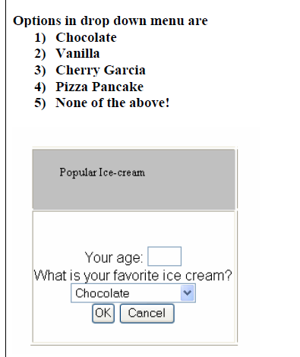

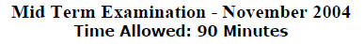

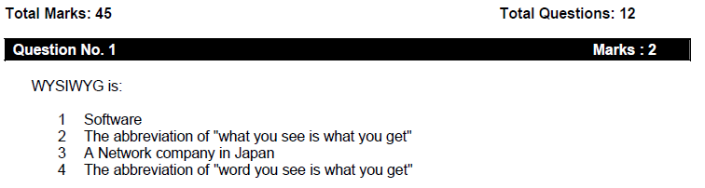


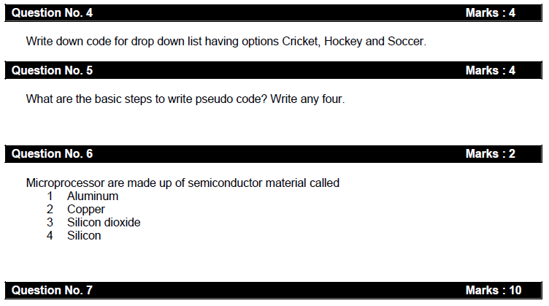
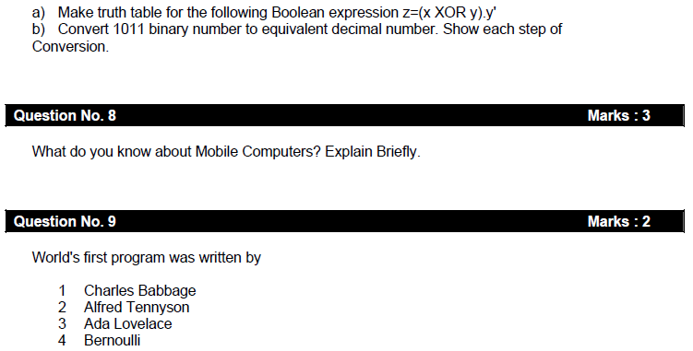
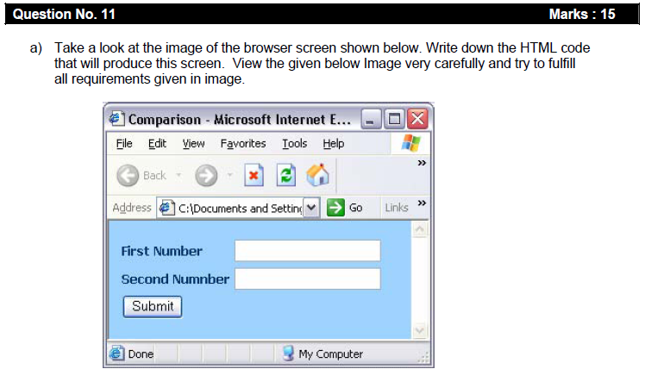

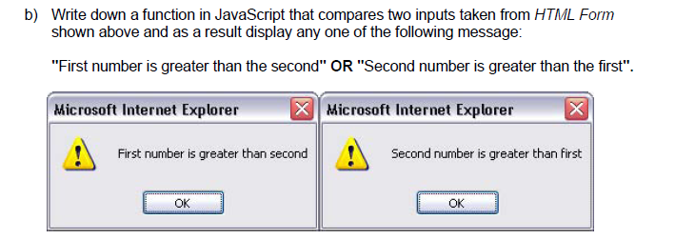
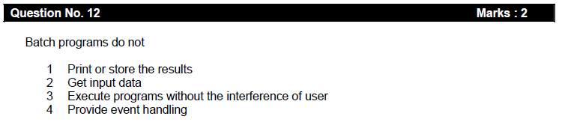

MIDTERM EXAMINATION
Fall 2008
CS101- Introduction to Computing (Session - 2)

Question No: 1
consists of cells arranged in rows & columns
► Spreadsheets Software
► Word processor
► Presentation Software
► Microsoft Paint Software

Question No: 2
manages the HW and SW resources ( memory, disk drives etc) of the computer system, often invisibly.
► Explorer.exe
► System Files
► Operating System
► Application Software

Question No: 3
Forms can be submitted through _______ & _______ methods
► INCLUDE, POST
► INCLUDE, GET
► GET, POST
► SEND, POST
Question No: 4
To display a checkbox on the web page, we use ___ tag
► CHECKBOX
► CHECK
► INPUT
► INPUTBOX
Question No: 5
You can ________ from/to a website containing interactive forms.
► Only read
► Only write
► Read and write
► Not read and write
Question No: 6
There is a battery on the motherboard to:
► Give power to the processor
► Save information when computer is off
► Save information when computer is on
► Give power to the motherboard

Question No: 7
We can change the background color in HTML, using ___ attribute of <body>

► background
► bgcolor
► backcolor
► backgroundcolor

Question No: 8
___ contains the name of the protocol required to access the resource, a domain name that identifies a specific computer on the internet and a pathname on the computer
► HTML
► HTTP
► URL
► WWW

Question No: 9
______ is a client program that uses HTTP to make requests to Web servers throughout the internet on behalf of the user.
► Web Application
► Web Browser
► Internet Application
► HTML

Question No: 10 ( Marks: 1 ) - Please choose one
WWW stands for:
► Wide World Web
► World Wide Web
► World White Web
► World Web Wide

Question No: 11 The weaknesses of the computer are:
► Pattern recognition & Storage
► Speed & Innovative ideas
► Pattern recognition & Innovative ideas
► Speed & Storage

Question No: 12
Floating point unit is also known as _________ unit
► Real
► Integer
► Numeric
► Fractional

Question No: 13
Programs that reside on Web servers and receive info that a user enters in a form, are known as:
► Server-Side Scripts
► Client-Side Scripts
► Super Scripts
► Form Scripts
Question No: 14
------------ is volatile memory
► RAM
► ROM
► Hard Disk
► CD ROM
Question No: 15
What will be the result of the following formula in Spreadsheet application ?
SUM(A2:A3) =_________(Assume that A2 = 25 A3 = 75)
► 25
► 50
► 75
► 100
Question No: 16
VisiCalc was the first popular _______application on PC’s
► Spreadsheet
► Word processor
► Presentation
► Database

Question No: 17
____________ is a system software that converts the source code written in high level language into machine language code.
► Utilities
► Drivers
► Language Translator
► None of the these
Question No: 18
What happens if I start a new list without closing the original one?
► An error will be generated
► A nested list will be created
► Previous list will end and a new will start.
► Nothing will happen
Question No: 19
__________ is a program that executes instructions line by line written in a high-level language.

► Interpreter
► Compiler
► Predictor
► Executor

Question No: 20
There are_________________ rules to write the Pseudo Code.
► Standard
► No standard
► Strict
► Pre-defined

Question No: 21 Which one is not the building block of an algorithm?
► Statements
► Sequences
► Repetitions
► Conditionals

Question No: 22 ( Marks: 1 ) - Please choose one
In flow charts, there is only one entry point in conditions while there is/are__________ exit points.
► 1
► 2
► 3
► 4

Question No: 23
A procedure that usually but not always works or that gives nearly the right answer is called_____________
► Deterministic Algorithm
► Heuristic Algorithm
► Greedy Algorithm
► Randomized Algorithm
Question No: 24
A Modem is a kind of ___
► Input device
► Output device
► Storage device
► Input and Output device

Question No: 25
The memory size of the Altair 8800 was
► 128 bytes
► 128 Kilo bytes
► 256 Kilo bytes
► 256 bytes

Question No: 26
---------- was known as “mill” in Analytical engine.
► Memory
► Processor
► Monitor
► Mouse

Question No: 27 (Marks: 1 )
What is the key feature of object-oriented design?

Question No: 28 (Marks: 1 )
Write one purpose of using spreadsheets?
Question No: 29 (Marks: 2 )
List down two advantages of writing Pseudo Code
Question No: 30 ( Marks: 3 )
How can we calculate total number of rows in the truth table?
Question No: 31 ( Marks: 5 )
Differentiate between Vector graphics and Bit-mapped graphics.
Question No: 32 ( Marks: 5 )
Write differences between Shareware and trail ware software.

MIDTERM EXAMINATION
Spring 2009
Time: 60 min Marks: 43

Question No: 1
A diode functions as the electronic version of a __________-way valve.
► one
► two
► three
► four

Question No: 2
What is name of book from which word algorithm is taken ?

► Algebra and trigonometry
► Introduction to algorithms
► Research for new horizons
► Algoritmi de numero Indorum
Question No: 3
<form> Tags always placed between the <BODY> and </BODY> tags of a Web page
► True
► False

Question No: 4
_______ consists of cells arranged in rows & columns
► Spreadsheets Software
► Word processor
► Presentation Software
► Microsoft Paint Software

Question No: 5
_____ was designed as a replacement for typewriter
► Spreadsheet Software
► Word Processor Software
► Presentation Software
► Database Software

Question No: 6
_________ manages the HW and SW resources ( memory, disk drives etc) of the computer system, often invisibly.
► Explorer.exe
► System Files
► Operating System
► Application Software

Question No: 7 To display a radio button on the web page, we use ___ tag
► INPUTBUTTON
► INPUT
► RADIOBUTTON
► RADIO

Question No: 8
Machine language is also called
► Assembly Language
► Binary Language
► High Level Language
► HTML Language

Question No: 9
When the user needs something to be done by the computer, he/she gives instructions in the form of _____ to computer ____
► Software, Hardware
► Hardware, Software
► System Software, Application Software
► Graph, Monitor

Question No: 10
A truth table defines the _________of a logic function for all possible _________
► Input -- Outputs
► Output -- Inputs
► Process -- Inputs
► Input -- Processes

Question No: 11
Which one is correct?
► <BODY></BODY>
► <body></body>
► Both <BODY></BODY> and <body></body>
► <BODY/>

Question No: 12
WWW stands for:
► Wide World Web
► World Wide Web
► World White Web
► World Web Wide

Question No: 13
A _________translates a high-level language (that is easy to understand for humans) into a language that the computer can understand
► Computer
► Transistor
► Compiler
► Device

Question No: 14
Deep Blue was the name of
► computer
► human
► city
► game

Question No: 15
Data travels through bus in the form of ---------------------------
► Packets
► Bits
► Bytes
► Word

Question No: 16
Command which saves the selected text before deleting is
► Copy
► Delete
► Cut
► Undo

Question No: 17
AutoCAD falls in the category of _________________
► Engineering Applications
► Graphics Applications
► Scientific Applications
► Business Applications

Question No: 18
In Spreadsheets, you can create a relationship between two cells by using _____.

► Numbers
► Text
► Formulas
► None of the given choices

Question No: 19
Which of the following symbol is used for multiple line comments in JavaScript?

► /
► //
► /*
► //*

Question No: 20
____________ is a system software that converts the source code written in high level language into machine language code.
► Utilities
► Drivers
► Language Translator
► None of the these
Question No: 21
__________ is a particularly good language for processing numerical data, but it does not lend itself very well to large business programs
► BASIC
► PASCAL
► JAVA
► FORTRAN

Question No: 22
Which of the following number system is used by microprocessor?
► Binary
► Decimal
► Octal
► Hexadecimal

Question No: 23
The __________Processor is specially designed for PDA?
► PowerPC
► StrongARM
► Crusoe
► SPARC
Question No: 24
Mainframe Computers are also called _____
► Enterprise Servers
► Personal Servers
► Enterprise Managers
► Window Servers
Question No: 25
URL is a/an ________
► Device
► Component
► Address
► Tool

Question No: 26
Ada, Countess of Lovelace developed first:
► Computer
► Website
► Computer Program
► Analytical engine

Question No: 27 ( Marks: 1 )
What is the problem with Brute Force Strategy approach?
Question No: 28 ( Marks: 1 )
What was the name of first computer in which binary numbers were used instead of decimal numbers ?
Question No: 29 ( Marks: 2 )
How can we say that JavaScript is Not Object-Oriented language?
Question No: 30 ( Marks: 3 )
List down the names of any three parameters on which we analyze an algorithm.
Question No: 31 ( Marks: 5 )
Write differences between Shareware and Trialware software.
Question No: 32 ( Marks: 5 )
What is function of Goal Seek command in Excel?
MIDTERM EXAMINATION
Spring 2009
(Session - 6)
Time: 60 min Marks: 43

Question No: 1
Cray-1 was first commercial _________ computer
► Super
► Mini
► Micro
► Personal

Question No: 2
Browser is a __________________ used for browsing.
► Tool
► Component
► Device
► None of the given choices

Question No: 3
It represents the _____________ flow chart element.
► Flow Line
► Connector
► Off-page connector
► Start or Stop

Question No: 4
JavaScript is an example of _____________ language.
► Object-based
► Object-oriented
► Machine
► Assembly

Question No: 5
The set of rules and guidelines a team of developers follow to construct reasonably complex SW systems is called

► Object Oriented Design
► Object Oriented Software
► Design Methodology
► Programming language

Question No: 6
Waterfall is a _________ life-cycle model.

► Spiral
► Sequential
► Circular
► Spherical

Question No: 7
What happens if I start a new list without closing the original one?
► An error will be generated
► A nested list will be created
► Previous list will end and a new will start.
► Nothing will happen

Question No: 8
In Spreadsheets, you can create a relationship between two cells by using _____.
► Numbers
► Text
► Formulas
► None of the given choices

Question No: 9
VisiCalc was the first popular _______application on PC’s.

► Spreadsheet
► Word processor
► Presentation
► Database

Question No: 10
Fins are used to --------------

► Communicate with microprocessor
► Increase surface area of Fan
► Decrease surface area of Fan
► Speed up the Fan.

Question No: 11
Using only HTML we can create

► Dynamic web pages
► Static web pages
► Both Static and Dynamic pages
► None of these

Question No: 12
Everything that JavaScript manipulates is treated as:
► Object
► Window
► Text
► Script

Question No: 13
The ______ is connected to all other modules of the microprocessor.

► Control unit
► Memory unit
► Floating Point unit
► Arithmetic and Logic unit

Question No: 14
Communication protocol is a __________that governs the flow of information over a network
► Set of protocols
► Set of rules
► Device
► Set of methods

Question No: 15
_________ is the interface in computer that supports transmission of multiple bits at the same time.
► Serial Port
► Parallel Port
► Universal Serial Bus
► None of the given choices

Question No: 16
_____ was designed as a replacement for typewriter
► Spreadsheet Software
► Word Processor Software
► Presentation Software
► Database Software

Question No: 17 Which one of these translates the program once at a time ?
► Interpreter
► Compiler
► Operating system
► Translator
Question No: 18
Randomized algorithms are often ________ than deterministic algorithms for the same problem.
► Simpler and more slow
► Simpler and more efficient
► Complex and more efficient
► Complex and more slow
Question No: 19
Ada written a computer programme for ?
► Analytical Engine
► Difference Engine
► Harvard Mark 1
► Mechanical engine
Question No: 20
A test proposed to determine if a computer has the ability to think. It is called?
► Turing test
► Turning test
► Intelligence test
► None
Question No: 21
The most used form tag is the <input> tag.
► True
► False
Question No: 22
When the user clicks on the "Submit" button, the content of the form is sent to the server.
► True
► False
Question No: 23
Extension for saving web page is / are;
► *.html
► *.htm
► *.html and *.htm both are in use
► None of These
Question No: 24
In spread sheet a cell may contain
► Numbers
► Text
► Formulas
► All of the given

Question No: 25
Programs where no user interaction found during program execution are called __________.

► Batch programs
► Event-driven programs
► Graphics based programs
► None of the given

Question No: 26
OO software is all about _____________.

► Behaviors
► Methods
► Properties
► Objects
Question No: 27 (Marks: 1 )
What is the key feature of batch programs?

Question No: 28 (Marks: 1 )
Name two languages which are used for client side scripting?

Question No: 29 (Marks: 2 )
What is the purpose of MODEM ?

Question No: 30 ( Marks: 3 )
What is Home Page of a web site?

Question No: 31 ( Marks: 5 )
Why microprocessor uses the binary number system and not the decimal or any other number system?

Question No: 32 ( Marks: 5 )
What is the difference between Interactive-mode and Batch-mode Application Software?

