CS301 Solved Quiz NO-1 Fall 2012

Which one of the following is TRUE about recursion?
1. Recursive function calls consume a lot of memory.
2. Recursion extensively uses stack memory.
3. Recursion extensively uses stack memory.
4. Iteration is more efficient than iteration.
Which of the following is not a data structure ?
1. Linked list
2. Queue
3. stack
4. Memory cell
“+” is a _________operator.
1. Unary
2. Binary
3. Ternary
4. None of the above
When an executable program run, it is loaded in the memory and becomes a_______.
1. Thread
2. .h file
3. Process
4. None of the above
www.vustudents.ning.com
In array list the worst case of removing an element is
1. To remove an element from the end of the list
2. To remove an element from the middle of the list
3. To remove an element from the start of the list
4. =We cannot remove element from an array list
The tree data structure is a
1. Linear data structure
2. Graphical data structure
3. Non-linear data structure (Not Confirm)
4. Data structure like queue
To create a _________ we link the last node with the first node in the list.
1. Double linked list
2. Circularly-linked list
3. Linked list
4. None of the above
In______, a programmer uses two pointers in the node, i.e. one to point to next node and the other to point to the previous node.
1. Linked list
2. doubly-link list
3. array
4. structure
Each operator in a postfix expression refers to the previous ______ operand(s)
1. one
2. two
3. three
4. four
Which of the following operations returns top value of the stack?
1. push
2. pop
3. top
4. First

Quiz No-2 Fall 2012
1.When an executable program run, it is loaded in the memory and becomes a_______.
Select correct option:
Thread
.h file
Process
None of the above

2.A kind of expressions where the operator is present between two operands called ________expressions.
Select correct option:
Infix
Postfix
Prefix
None of the above

3.Which of the following operations returns top value of the stack?
Select correct option:
push
pop
top
first

4.To create a _________ we link the last node with the first node in the list.
Select correct option:
Double linked list
Circularly-linked list
Linked list
None of the above

5.In the calling function, after the execution of the function called, the program continues its execution form the _______after the function call.
Select correct option:
Previous line
Next line
Beginning
None of the above

6.Doubly Linked List always has one NULL pointer.
Select correct option:
True
False
7. ________ only removes items in reverse order as they were entered.
Select correct option:
Queue
Stack
Both of these
None of these

8.In the linked list implementation of the stack class, where does the push member function places the new entry on the linked list?
Select correct option:
After all other entries that are greater than the new entry.
At the head
After all other entries that are smaller than the new entry.
At the tail

9.Which of the following is known as "Last-In, First-Out" or LIFO Data Structure?
Select correct option:
Linked List
Stack
Queue
Tree

10.Which boolean expression indicates whether the numbers in two nodes (p and q) are the same. Assume that neither p nor q is null.
Select correct option:
p == q
p.data == q.data
p.nextNode == q. nextNode
p.data ==

CS301 1st Quiz 9th may, 2012
www.vustuden





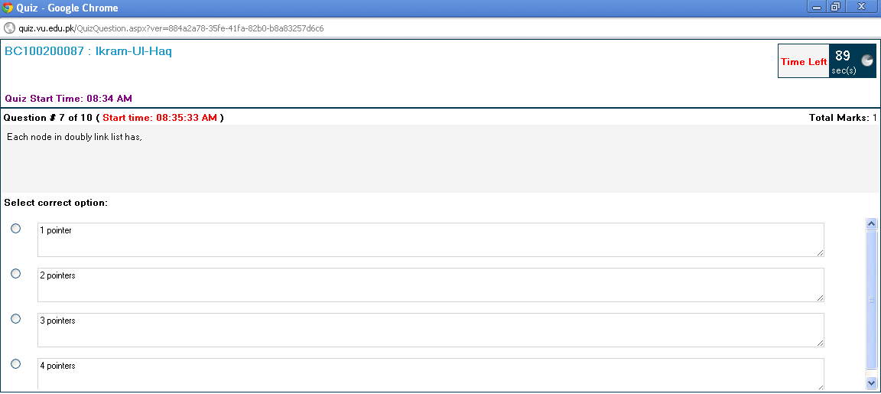




ts.ning.com

Quiz # 01 CS301 Fall 2012





